Ms. Diehl
College Preparatory English
Summerville High School
“There are no great limits to growth because there are no limits of
human intelligence, imagination, and wonder.”
–Ronald Reagan

The Proper Way to Write a Research Body Paragraph

It is a tragedy that funding for special education programs and athletics is diminishing from hundreds of schools in the United States as there are many positive aspects of combining these two entities in order to help students grow and achieve success. According to the article, “The Adaptive Sports Program,” “Developing a sense of self-esteem and confidence is an extremely important part of special education” (1). When reflecting upon students in general and analyzing behavior in the classroom, it is increasingly clear that students who find
success by being taught to their academic levels and modes of learning are going to find much more confidence regarding their achievement as a student and as an overall person. Likewise, if students are provided small classrooms, athletic programs to help aide in learning, and good teachers who are skilled in honing in on their
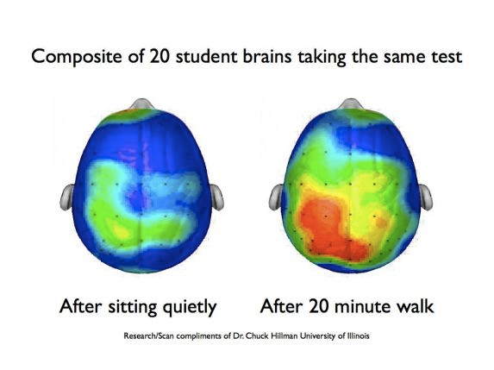
The picture of these two student brains prove the importance of combining athletics and learning in all educational environments. When students combine kinesthetic activity with learning, it becomes clear, especially when reviewing the statistics and tests, that students who are involved in some kind of physical activity, reap the benefits when completing assignments and taking tests (Hilman 1).
academic and athletic skills, this success is inevitable. This article goes on to explain other benefits of special education and sports going hand-in-hand, as they assert, “The hands-on aspect of sports leads to cognitive skill improvement in people with disabilities and allows them to discover and access strengths that cannot be challenged in other settings” (1). As referred to in the above diagram, it is beneficial to brain activity when a student is active (Hilman 1). These profound words help further illuminate how crucial it is to offer individualized education for students in need and athletic activities that will give students an opportunity to enjoy school, learn new skills, and improve brain development, communication skills, and practical life skills learned through the structure and organization athletics provide. Consequently, it is the goal of all educational institutions to help 100 percent of their students become proficient or above in all areas of learning, specifically math and English, which is one of the reasons the benefits of special programs should not be overlooked. Upon synthesizing all of the research regarding how beneficial it is to allow special education students to be provided athletic programs, it is undeniably clear that schools are doing a disservice to those who are not given these phenomenal opportunities that are the catalysts to success.

